V-Sem Mini Project Report on

MOVIE EXPLORER

Submitted in partial fulfilment of the requirement for the award of the degree of

BACHELOR OF TECHNOLOGY

IN

COMPUTER SCIENCE & ENGINEERING (AI/ML)

Submitted by:

Student Name: Roll No:
TAGARAM SONALIKA 24981A428P
MAMIDI RISHITH KUMAR 24981A425I
CHENNA VARUN 24981A426U
GUTTI INDU VALANI 24981A424Y
CHODISETTI TEJESWARARAO 24981A426X

Under the Guidance of

K SANDEEP KUMAR
Assistant Professor



Raghu Engineering College
Department of Computer Science and Engineering (AI/ML)
Dakamarri, Visakhapatnam
2026-27

CANDIDATE’S DECLARATION

I hereby certify that the work which is being presented in the project report entitled MOVIE EXPLORER in partial fulfilment of the requirements for the award of the Degree of Bachelor of Technology in Computer Science and Engineering (AI/ML) in the Department of Computer Science and Engineering(AI/ML) of the Raghu Engineering College shall be carried out by the undersigned under the supervision of K SANDEEP KUMAR, Assistant professor, Department of Computer Science and Engineering(AI/ML), Raghu Engineering College Visakhapatnam.
Name: Roll no: Signature
TAGARAM SONALIKA 24981A428P
MAMIDI RISHITH KUMAR 24981A425I
CHENNA VARUN 24981A426U
GUTTI INDU VALANI 24981A424Y
CHODISETTI TEJESWARARAO 24981A426X
The above-mentioned student shall be working under the supervision of the undersigned on the
MOVIE EXPLORER

Project Guide & Supervisor Head of the Department CSE(AI/ML)
K SANDEEP KUMAR Dr. G SRIDEVI
Assistant Professor Associate Professor
Examination

Name of the Examiners: Signature with Date
1. Dr. G Sridevi (INTERNAL)
2.

ACKNOWLEDGEMENT
I express my sincere gratitude to the management, Principal, Head of the Department, project guide, faculty members and staff of Raghu Engineering College for their valuable guidance and support during the development of this mini project. I also thank my classmates and friends for their suggestions and encouragement. Finally, I thank my family for their continuous support throughout the project.

Team members

ABSTRACT

The Movie Explorer is a web-based application developed to provide a structured and accessible platform for browsing, searching, and exploring a collection of movies. The primary objective of the project is to demonstrate the practical application of fundamental front-end web development concepts while providing users with efficient mechanisms for locating and examining movie information. The system is designed to organize movie data and support interactive exploration through a simple and responsive user interface.

The application is designed to make movie exploration convenient by presenting movie information in an organized and user-friendly manner. Users can browse the available collection and interact with the displayed movie information through a simple interface. The system focuses on reducing the effort required to locate specific movies and provides an effective way to examine the available collection.

The project is implemented exclusively using HTML, CSS, and JavaScript. HTML is used to define the semantic structure and organization of the application, while CSS is employed for presentation, layout, and responsive design. CSS Grid and Flexbox are used to create an adaptive interface that accommodates different screen sizes. JavaScript provides the application's dynamic functionality by managing movie data through arrays and objects, manipulating the Document Object Model (DOM), and implementing event-driven programming to respond to user interactions.

The application provides major features including movie search by title, genre-based filtering, sorting by rating and release year, and access to detailed movie information through interactive components. Users can search for a particular movie, filter movies according to genre, and organize the collection based on rating or release year. User actions dynamically update the displayed movie collection without requiring changes to the underlying page structure.

The resulting application demonstrates the integration of structural, presentation, and behavioral aspects of client-side web development within a single system. It provides practical experience in data handling, DOM manipulation, responsive interface development, and interactive programming. The project also establishes a foundation for future extensions, such as incorporating additional movie data and developing more advanced functionality while retaining the core front-end technologies.

Table of Contents
1. INTRODUCTION 1
1.1 Purpose 1
1.2 System Overview 1
1.3 Problem Statement 1
1.4 DFD Modelling of Problem 2
1.5 Goal & Vision 2
2. REQUIREMENTS SPECIFICATIONS 3
2.1 User Characteristics 3
2.2 Functional Requirements 3
2.3 Dependencies 5
2.4 Performance Requirements 6
2.5 Hardware Requirements 6
2.6 Constraints & Assumptions 7
3. DESIGN 8
3.1 Function Oriented Design for procedural approach 8
3.2 Database Design 9
3.3 GUI Design for front-end 10
4. CODING 17
5. TESTING 24
5.1 Test Plan 24
5.2 Test Report 24
6. INSTALLATION INSTRUCTIONS 27
7. END-USER INSTRUCTIONS 27
8. FUTURE WORK 29
9. SUMMARY 31
10. REFERENCE 33

Introduction

Movie Explorer is a web-based application designed to help users easily discover, search, and explore movies. It provides a user-friendly interface to browse movies, explore different genres, and view movie details. The main objective of this project is to make movie discovery simple, convenient, and enjoyable through an interactive and responsive website.

  - Purpose

The purpose of this document is to provide a detailed description of the Movie Explorer website. It explains the objectives, functionality, and overall design of the system. It also describes the interactions between the user interface (HTML and CSS), the application logic (JavaScript), and the data source used to store or retrieve movie information. This document is intended for project team members, faculty, and other stakeholders who want to understand how Movie Explorer works, its intended uses, and its potential for future enhancements.

1.2 System Overview

Movie Explorer is a web-based movie discovery and exploration platform that allows users to search for movies, browse different genres, and view movie information through a single interface. Users can explore movie collections, search for specific titles, and discover films based on their interests. The website presents movie posters, titles, ratings, release years, and other relevant details, depending on the available movie data.
The system provides an interactive and user-friendly interface that simplifies movie browsing and discovery. Users can navigate between different sections, explore movie categories, and access detailed information about selected films. The application uses HTML and CSS to structure and style the interface and JavaScript to handle user interactions and application logic. Movie information can be obtained from a local dataset or an external movie API, depending on the implementation.
The main objective of Movie Explorer is to make movie discovery simple, organized, and convenient. The system can be enhanced in the future with features such as personalized recommendations, watchlists, advanced filters, and integration with streaming platforms.

1.3 Problem Statement

Finding movies that match personal interests can be challenging when movie information is scattered across different websites and platforms. Users may find it difficult to search for specific movies, explore different genres, compare available options, and access relevant movie details in one place. This can make the movie discovery process time-consuming and inconvenient.

Movie Explorer addresses this problem by providing a centralized, user-friendly platform for searching, browsing, and exploring movies. It organizes movie information into an interactive interface, allowing users to discover films, explore different categories, and view available movie details conveniently. The system aims to make movie discovery faster, simpler, and more enjoyable.

1.4 DFD Modelling of Problem
The Movie Explorer web application accepts search queries and filter selections from users. The application retrieves and organizes movie data, applies genre filters and sorting by rating or release year, and displays movie details. Movie data is maintained in the application, while the search and filtering operations dynamically update the displayed collection.
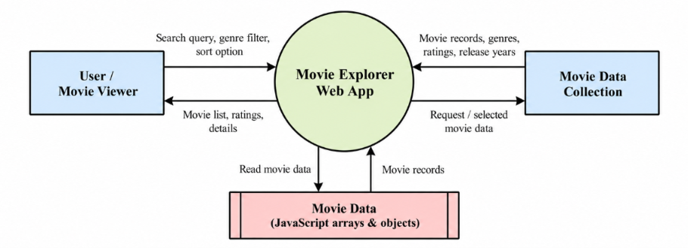
Figure 1. DFD of a Problem (Context Level)
1.5 Goal & Vision

The Movie Explorer website aims to provide a simple, interactive, and user-friendly platform for discovering and exploring movies. The main goal is to bring movie information together in one place, making it easier for users to search for films, explore different genres, and access relevant movie details without switching between multiple websites.
The system is designed to improve the movie discovery experience by providing organized movie collections, convenient search functionality, and an attractive interface. It helps users discover movies according to their interests and make informed decisions about what to watch.
Movie Explorer also provides a foundation for future enhancements, such as personalized recommendations, advanced filtering, watchlists, user ratings, and integration with external movie databases. These improvements can make the platform more comprehensive, engaging, and convenient for users.
The long-term vision of Movie Explorer is to develop into a comprehensive movie discovery platform that brings movie information and exploration features together in one accessible place, making it easier and more enjoyable for users to find their next favourite movie.

2. Requirements Specification
There are two main types of users who interact with the Movie Explorer website:

2.1 Users Characteristics

General Users: People who want to discover, search, and explore movies.
Movie Enthusiasts: Users who frequently browse different movie genres, check movie details, and look for new films to watch.

Both types of users interact with the system through a web browser. General users want to search for specific movies, browse available collections, and view information about films. Movie enthusiasts want to explore different genres, compare movie details, and discover movies according to their preferences.

Users interact with the application through a user-friendly web page that provides movie posters, titles, search options, genre categories, and other available movie information. Users can enter a movie title in the search bar, select a genre, browse the displayed results, and click on a movie to view its details, such as its description, release year, rating, and genre.

The system is designed to be simple and accessible, requiring no advanced technical knowledge. Its interactive interface allows users to navigate between movie listings and individual movie details easily, providing a convenient and enjoyable movie discovery experience.

2.2 Functional Requirements

The functional requirements describe the main operations and features provided by the Movie Explorer website. These requirements explain how users interact with the system to search for movies, explore genres, view movie details, and discover films.

User Class 1 – General Users
Functional Requirement 1.1 – Browse Movies

Actor: User
Input: None
Description: Given that the user has opened the Movie Explorer website in a browser, the system displays the available movies in an organized layout containing movie posters, titles, and other available information. The user can browse the movie collection and select a movie to view further details.

Functional Requirement 1.2 – Search for Movies

Actor: User
Input: Movie title or keyword
Description: The user enters a movie title or keyword in the search bar. The system processes the input and displays matching movies. If no matching movies are found, the system displays an appropriate message indicating that no results are available.

Functional Requirement 1.3 – Explore Movies by Genre

Actor: User
Input: Selected movie genre
Description: The user selects a genre, such as action, comedy, drama, thriller, or romance. The system displays movies belonging to the selected genre, allowing users to discover films according to their interests.

Functional Requirement 1.4 – View Movie Details

Actor: User
Input: Selected movie
Description: The user clicks on a movie poster or title to view its details. The system displays the available information, which may include the movie title, poster, description, release year, genre, rating, and other relevant details.

Functional Requirement 1.5 – Filter Movies

Actor: User
Input: Selected filter criteria
Description: The user selects available filtering options to narrow down the movie collection. Depending on the implemented features, filters may include genre, release year, rating, or language. The system displays movies that match the selected criteria.

Functional Requirement 1.6 – Sort Movies

Actor: User
Input: Selected sorting option
Description: The user selects an available sorting option, such as movie title, release year, or rating. The system rearranges the displayed movie collection according to the selected option, making it easier to explore the available movies.

Functional Requirement 1.7 – Navigate Through the Website

Actor: User
Input: Navigation selection
Description: The user navigates between the available sections of the Movie Explorer website, such as the home page, movie listings, search results, and movie details. The system displays the selected section and allows the user to continue exploring movies.

User Class 2 – System
Functional Requirement 2.1 – Retrieve Movie Information
Actor: System
Input: Movie request or selected movie
Description: The system retrieves the required movie information from the available local dataset or external movie database API, depending on the implementation. It processes the information and presents the relevant results to the user.

Functional Requirement 2.2 – Display Search Results

Actor: System
Input: Search query
Description: The system compares the user's search query with the available movie information and displays matching results. If no matching movie is found, the system informs the user that no results are available.

Functional Requirement 2.3 – Update Movie Listings

Actor: System
Input: Search query, selected genre, or filter criteria
Description: The system updates the displayed movie collection according to the user's search, genre selection, or available filters. The results are presented in an organized format to support convenient movie discovery.

Functional Requirement 2.4 – Handle Invalid or Empty Inputs

Actor: System
Input: Empty search field or invalid input
Description: The system handles empty or invalid search inputs appropriately. It prevents unnecessary processing and provides suitable feedback so that users can correct their input and continue exploring movies.

2.3 Dependencies

Movie Explorer is a client-side web application that runs entirely in a web browser. It does not require an external API or a backend server to provide movie information. The website uses the following technologies:

HTML5: Used to create the structure of the website, including the home page, movie listings, search bar, navigation menus, and movie details sections.
CSS3: Used to design and style the website, including movie cards, posters, page layouts, animations, and responsive elements.
JavaScript (ES6): Used to implement application logic, including movie searching, filtering, genre selection, navigation, and displaying movie information.
Local Movie Dataset: Used to provide movie information such as titles, posters, genres, descriptions, release years, and ratings. The data is stored within the project files rather than retrieved from an external API.
Web Browser: Used to run the application and display its interface and functionality.
Visual Studio Code with Live Server: Used as the development environment for writing, testing, and running the website locally.
The application does not depend on external movie APIs or a dedicated backend server. Its functionality depends on the availability of the project files and the completeness of the local movie dataset.

2.4 Performance Requirements

Movie Explorer is designed to provide a fast, responsive, and smooth movie browsing experience. Since the website uses a local movie dataset and does not retrieve movie information from an external API, it avoids delays caused by API requests.

The website should load its main interface efficiently and display movie listings, posters, and details with minimal delay. Search results and other implemented interactive features should respond promptly to user actions.

The application should work properly in modern web browsers and provide a consistent experience on desktop and mobile devices. Movie images should be optimized to reduce loading time and memory usage.

Performance depends on the size of the local movie dataset, the number and resolution of images, and the efficiency of the JavaScript code. The website should handle empty search results and missing movie information appropriately to ensure a reliable user experience.

Because the application does not use an external API, movie information will remain limited to the data included in the project unless the dataset is manually updated.

2.5 Hardware Requirements

To access the Movie Explorer website, users need a computer, laptop, tablet, or smartphone with a modern and updated web browser.
Desktop Browsers: Google Chrome, Mozilla Firefox, Microsoft Edge, Safari, and Opera.
Mobile Browsers: Android Chrome and iOS Safari.

For developing and running the project, a computer that meets the following specifications is sufficient:
- Operating System: Windows, Ubuntu/Linux, or macOS.
- Processor: Intel Core i3 or equivalent processor.
- RAM: At least 4 GB.
- Storage: Sufficient free space to store the project files and movie images.
- Display: A standard monitor or laptop screen for development and testing.
- Development Tools: Visual Studio Code and a modern web browser.
- Testing Tool: Live Server extension for Visual Studio Code, if required.
Since Movie Explorer is a client-side web application that uses HTML, CSS, JavaScript, and a local movie dataset without an external API, it does not require a dedicated server or high-performance hardware for basic operation.

2.6 Constraints & Assumptions
Movie Explorer is a client-side web application that uses HTML, CSS, JavaScript, and a local movie dataset to provide movie discovery and browsing features. Since the application does not use an external API or a dedicated backend server, its functionality depends on the data and resources available within the project files.
The system assumes that users have access to a modern web browser and that the movie dataset contains accurate and relevant information. The quality of the displayed movie details depends on the completeness and correctness of the locally available data.

The following constraints and assumptions apply to the current version of the system:
- Local Movie Dataset: Movie information is obtained from the data included in the project files. New movies and updated information must be added manually to the dataset.
- No External API: The website does not retrieve movie information from external movie databases. Therefore, it cannot automatically provide real-time updates to movie ratings, descriptions, or release information.
- No User Authentication: The current version does not require users to create accounts or log in to access the movie browsing features.
- Limited Data Availability: The number of movies available for searching and browsing depends on the size and contents of the local dataset.
- Internet Connectivity: The basic website can run locally without an internet connection if all required files and movie images are stored locally. External image links, if used, require internet access.
- Browser Compatibility: The website is designed for modern browsers such as Google Chrome, Mozilla Firefox, Microsoft Edge, and Safari. Older browsers may not support all interface features.
- Language Support: The interface and available movie information depend on the languages included in the project. Additional language support may require modifications to the dataset and interface.
- Performance Limitations: Website performance depends on the size of the movie dataset, image file sizes, and the efficiency of the JavaScript code.
Movie Explorer is intended to simplify movie discovery and provide convenient access to available movie information. However, the accuracy and freshness of the information depend on manual updates to the local dataset. Features such as real-time movie updates, personalized recommendations, user accounts, and cloud-based watchlists may be considered for future development.

3. Design
3.1 Function Oriented Design for procedural approach

The Movie Explorer application is divided into five main processes: Browse Movies, Search Movies, Filter by Genre, View Movie Details, and Sort Movie Listings. These processes work together to help users discover and explore movies through an interactive web interface. The application uses HTML and CSS to display the content and JavaScript to process user action and manage movie information stored in the local dataset.

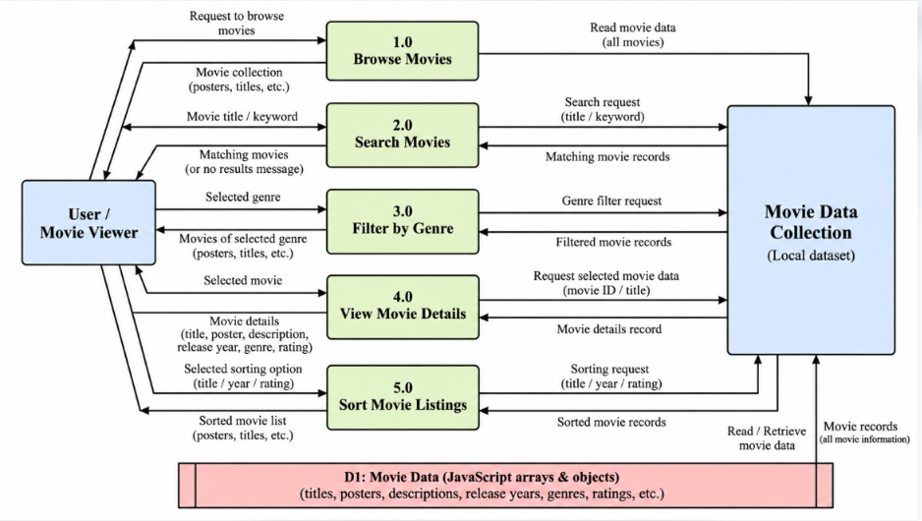
Figure 2. DFD of Application (Level 1)

The workflow of the Movie Explorer application begins when a user opens the website and browses the available movie collection. The user can search for a specific movie, select a genre, apply available filters, or choose a movie to view its details. The system processes the user's selection and displays the corresponding information.

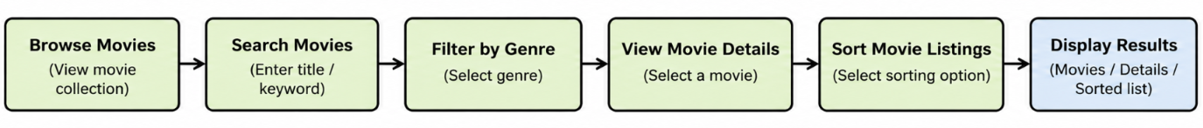
Figure 3. Status Flow of a Report

The inputs and outputs of each process of the application are summarized below:
- 1.0 Browse Movies: Displays the available movie collection using information from the local movie dataset. The output includes movie posters, titles, and other available information.
- 2.0 Search Movies: Takes a movie title or keyword as input and displays matching movies from the local dataset. If no matching movie is found, the system displays an appropriate message.
- 3.0 Filter by Genre: Takes the selected genre as input and displays movies belonging to that category, helping users explore films according to their interests.
- 4.0 View Movie Details: Takes the selected movie as input and displays its available information, such as title, poster, description, release year, genre, and rating.
- 5.0 Sort Movie Listings: Takes the selected sorting option as input and arranges the displayed movies according to the supported criteria, such as title, release year, or rating.

3.2 Database Design

Movie Explorer uses the browser’s local Storage to save user profile information and submitted movie reviews as JSON strings. These values are loaded when the application starts and updated when a user signs in or submits a review. Movie details and ratings are predefined in the application, and booking is simulated without saving booking records. Stored data is local to each user’s browser and is not shared or synchronized across devices.
Each report is one object. The history of the report is a list of objects kept inside the report, so one report has many history entries (1 : N). The fields of a report are as follows:
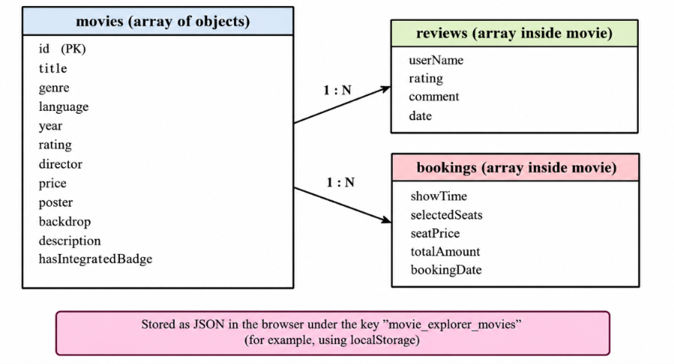
Figure 4. Data Structure of Movie Explorer

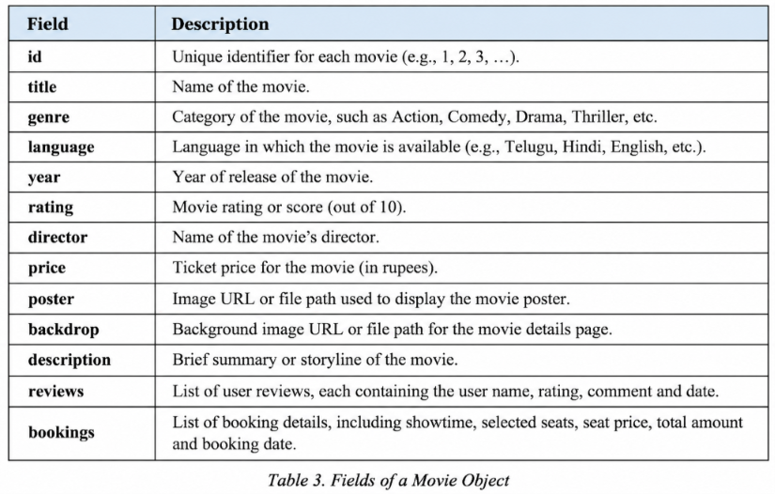
Table 1. Fields of a Report Object

3.3 GUI Design for Front-end

The front end of Movie Explorer is designed to be clean, responsive, visually appealing, and easy to use. Movie posters, rating badges, category filters, and clearly visible buttons help users explore movies and access booking features easily

- Consistent layout: A white header with the Movie Explorer logo, search bar, city selector, navigation links, and sign-in button is used to provide easy navigation. A dark slate-coloured secondary navigation bar complements the header.

- Card-based design: Movie information is organized into cards and grids on a light grey background (#f5f5f7). Rounded corners and subtle shadows improve readability and visual appearance.

- Clear actions: Pink-red buttons (#f84464) are used for primary actions, such as exploring a movie and starting the booking process. Separate controls are provided for searching, filtering, sorting, and browsing cinemas.
- Search and filters: The search bar allows users to search for movies or genres. Filter buttons allow browsing by language and genre, while the sorting menu arranges movies by highest rating, newest release, oldest release, or title in alphabetical order.
- Movie information and ratings: Movie cards and promotional banners display movie titles, posters, genres, languages, release years, and ratings. Recommended Movies and Coming Soon sections help users discover featured and upcoming films.
- Interactive elements: The home page includes a promotional banner carousel with navigation controls, a recommended movies section, and a Now Showing section with a responsive movie grid. Movie selection leads users toward the movie details and demo booking process.
The home page introduces the platform through the Movie Explorer brand and a promotional carousel featuring movies such as HanuMan, The Paradise, and Kalki 2898 AD. The Recommended Movies and Now Showing sections allow users to explore the available collection. The page also includes a Coming Soon section, city selection, and cinema browsing controls to provide a more complete movie discovery experience.
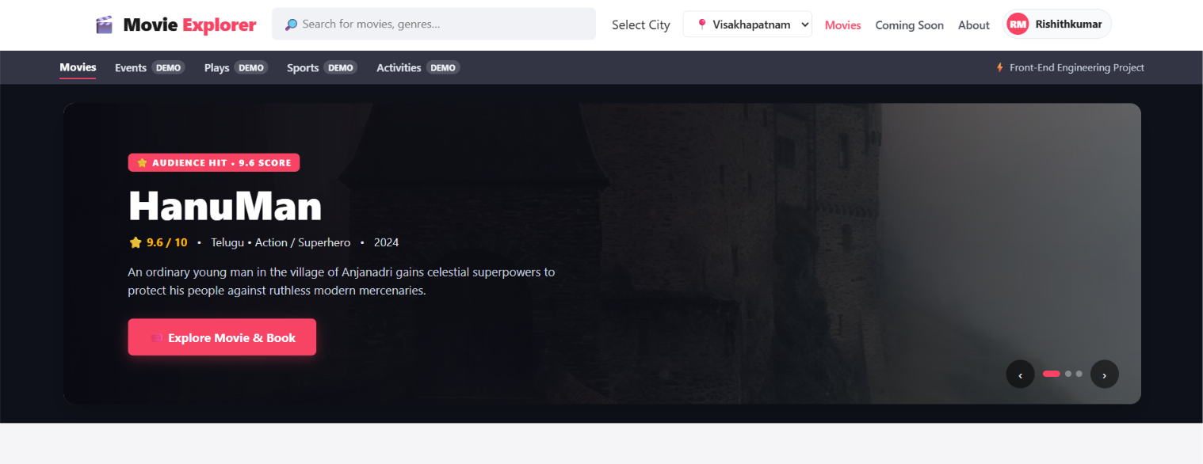
Figure 5. Screenshot of Home Page
The Movie Explorer page contains the main interface for discovering movies and starting the ticket-booking process. Users can search for movies by title or genre, select a language or genre filter, sort movies by rating or release year, view movie information, and browse available cinemas. The page also displays recommended movies, promotional banners, and upcoming releases.
The fields and controls available on the Movie Explorer page and their purpose are given below:
- Movie Search: Allows users to search for movies by title or genre.
- City Selection: Allows users to select a city, such as Visakhapatnam, Hyderabad, Bengaluru, or Chennai.
- Language Filter: Filters movies according to language, such as Telugu, Hindi, English, or Tamil.
- Genre Filter: Displays movies belonging to a selected genre, such as Action, Comedy, Drama, Romance, Science Fiction, Animation, or Thriller.
- Movie Rating: Displays the rating assigned to each movie and helps users compare available movies.
- Movie Sorting: Arranges movies by highest rating, newest release, oldest release, or alphabetical order.
- Movie Details: Displays information such as the movie title, poster, genre, language, release year, director, rating, and description.
- Recommended Movies: Displays selected movies for users to explore.
- Coming Soon: Shows information about upcoming movie releases.
- Browse by Cinemas: Provides a control for exploring cinema-related options.
- Explore Movie and Book: Allows users to start the movie selection and demo booking process.
The following rules are applied to the form before a report is submitted:
- The search field accepts a movie title or genre as input.
- The selected language or genre filter determines which movies are displayed.
- The sorting control arranges the movie list according to the selected option.
- The movie rating is displayed to help users compare movies and identify highly rated titles.
- The promotional carousel allows users to navigate between featured movies.
- Selecting a movie provides access to its details and the demo booking process.
- The city selector allows users to choose from the cities provided in the application.
- The movie listings are displayed in a responsive layout to support different screen sizes.
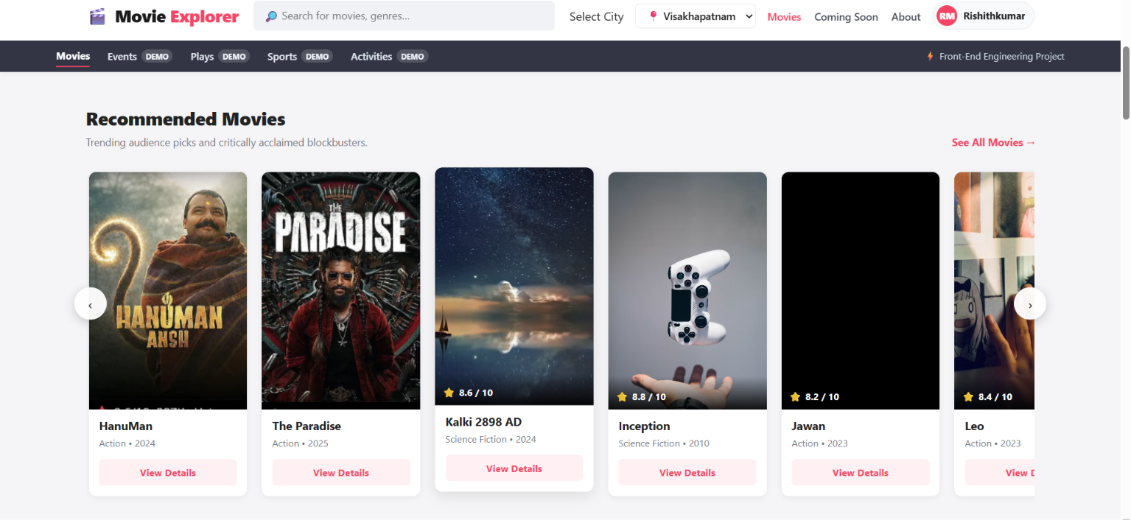
Figure 6. Recommended Movie Page
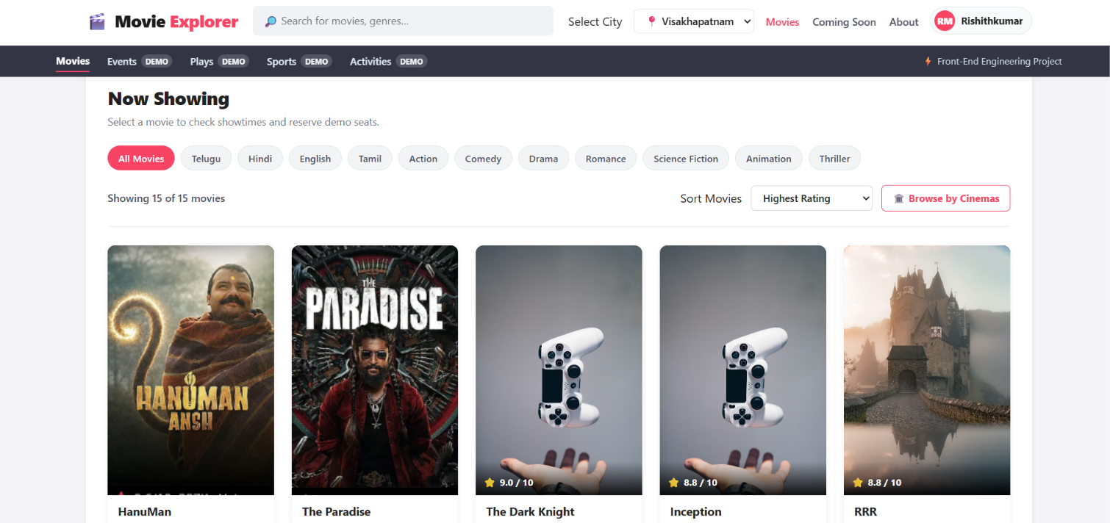
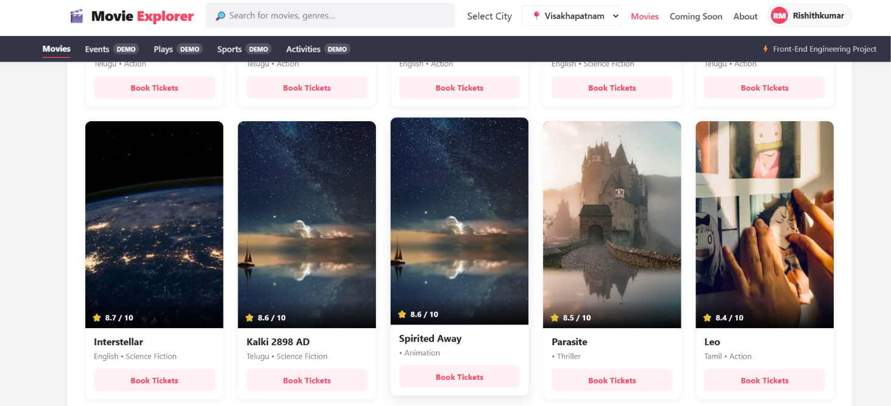
Figure 7. Movie Listing and Filtering Page
The Coming Soon section displays upcoming and anticipated movie releases in a card-based layout. Each movie card includes a poster, movie title, language, genre, and release date where available. The section features movies such as The Paradise, Avatar: Fire and Ash, Pushpa 2:The Rule, and War 2. Date labels and other badges provide information about upcoming releases and audience interest, helping users discover movies they may want to watch.

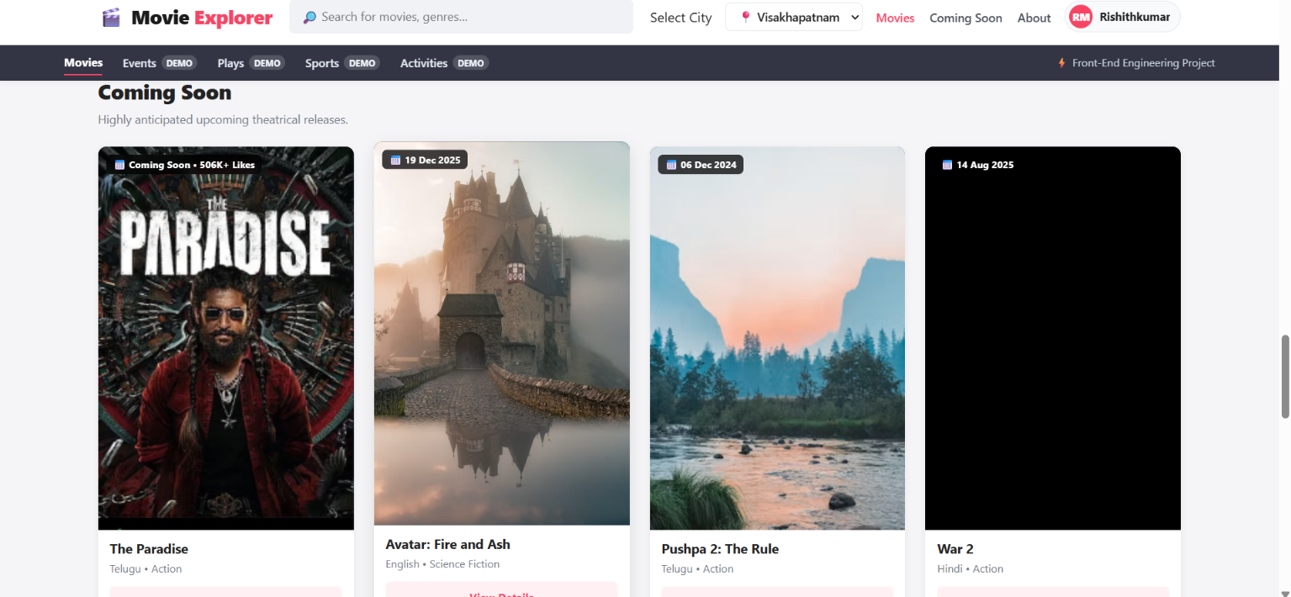
Figure 8. Screenshot of Coming Soon Page

Interface Features
All pages share a common navigation bar at the top with the buttons Home, Report Problem, Community and Track Problem, and a common footer, so that the user can move between the sections easily. The main interface features are:
- Responsive layout: Content is placed inside cards and grids that adjust to different screen sizes; on small screens the header, the hero section, the statistics and the form change to a one or two column layout.
- Priority and status labels: Every problem shows a category badge, a severity badge and its current status.
- Live problem analysis: While the user fills in the report form, the Risk Score, Priority Score and Priority Level are shown in the Problem Analysis box.
- Progress timeline and history: The tracking page shows the six stages as a timeline in which the completed stages are highlighted, and a dated history of the actions.
- Quick actions: The buttons “View Full Tracking” and “I’m Also Affected” are available directly on each problem card.
- 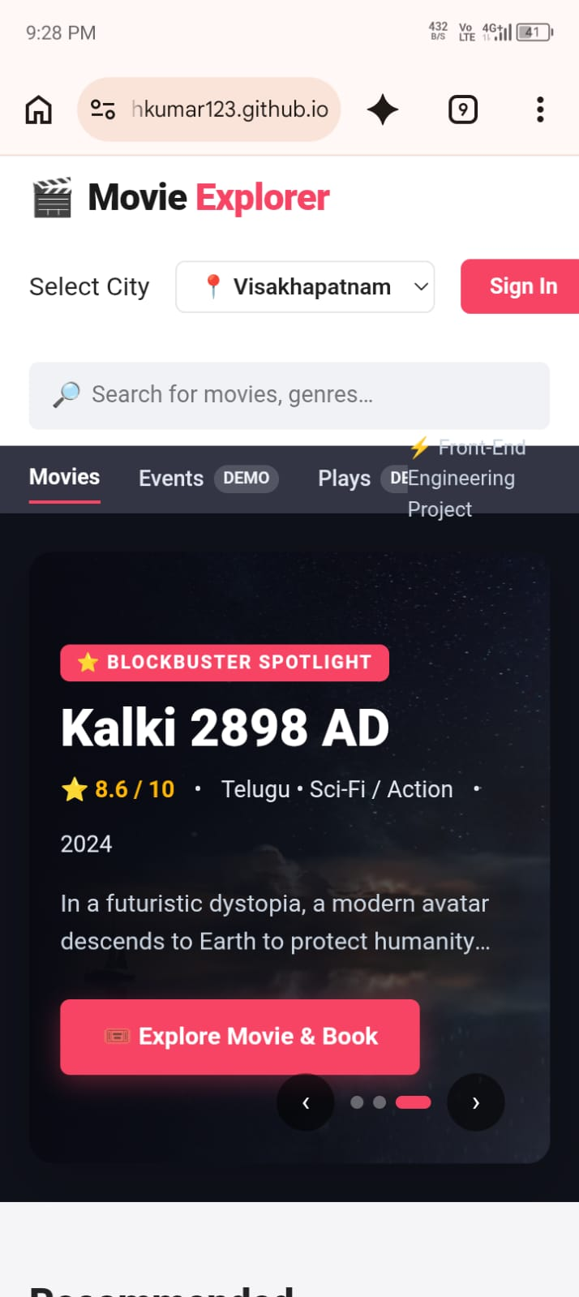

Figure 9. Responsive Layout at Mobile Screen Width
The sections of the application are:
- Home: Displays the promotional movie carousel, recommended movies, search bar, city selector, and navigation options to help users discover movies.
- Now Showing: Displays the available movie collection in a responsive grid. Users can search for movies, filter them by language or genre, and sort them by rating, release year, or title.
- Movie Details and Booking: Allows users to explore movie information, including the title, poster, genre, language, release year, director, rating, and description. Users can proceed to the demo booking process and select seats.
- Recommended Movies: Displays featured and recommended movies to help users discover popular titles.
- Coming Soon: Presents information about upcoming movie releases, including their titles, genres, release years, and descriptions.
- Browse by Cinemas: Provides an option to explore cinema-related choices through the application's interface.
- About: Provides information about the Movie Explorer application and its purpose.

4. Coding
This section shows the key parts of the implementation as they appear in the code editor (Visual Studio Code). The complete application is written in a single file, “fsd project.html”, which contains the HTML structure, the CSS styles inside the style tag and the JavaScript inside the script tag. The CSS for the hero section and the buttons is shown first.
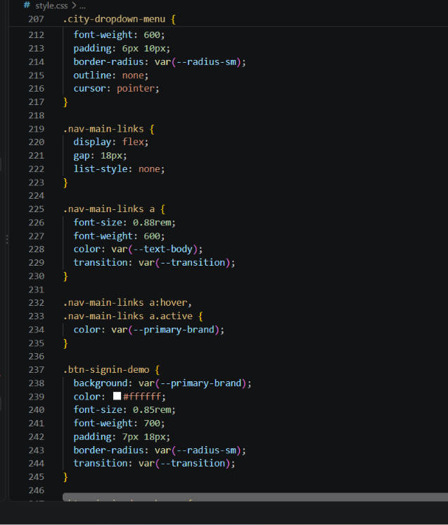
Figure 10.CSS(fsd project.html)
The header, navigation and the pages are built with HTML. The structure of the header and the navigation buttons that switch between the sections is shown below.
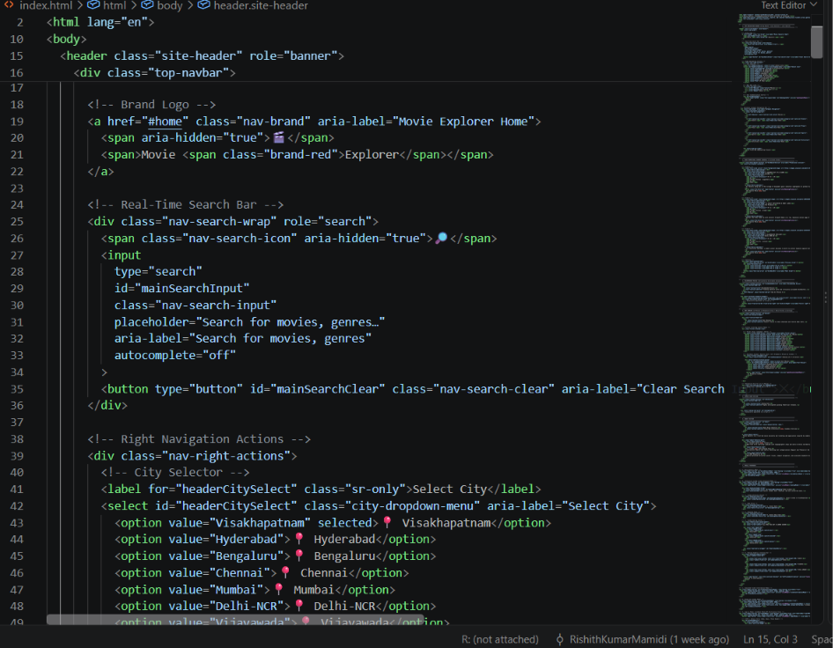
Figure 11. HTML of the Header, Navigation and Home Section

The application allows users to view movie reviews and ratings to evaluate movies before watching them. It also helps users explore and select movies based on their preferences, genres, ratings, and available movie information.
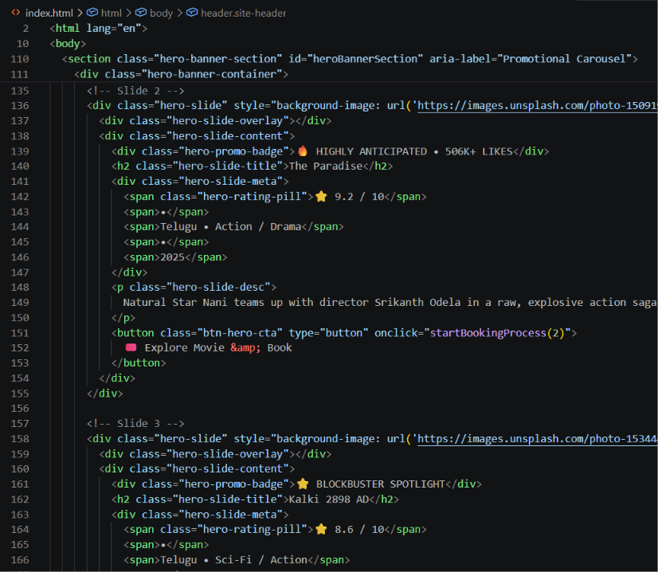
Figure 12. HTML of the Movie Displaying
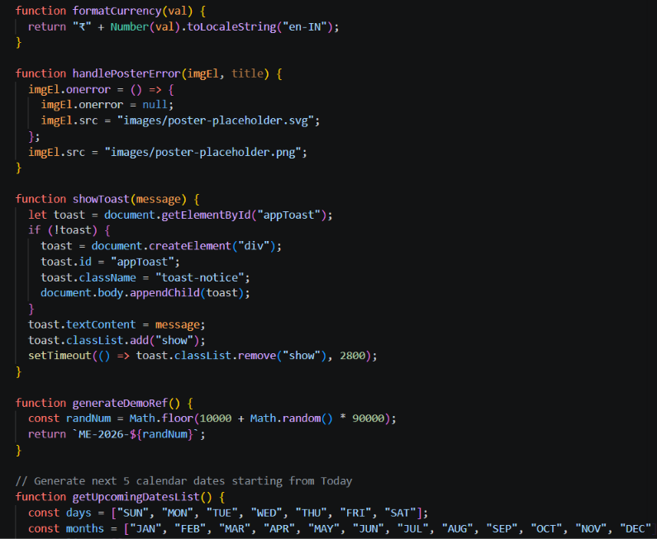
Figure 13. JavaScript
JavaScript handles the interactive functionality of the Movie Explorer application, including movie selection, searching, filtering, sorting, and displaying movie details. It also manages user ratings, reviews, seat selection, and booking amount calculations, making the application dynamic and user-friendly.
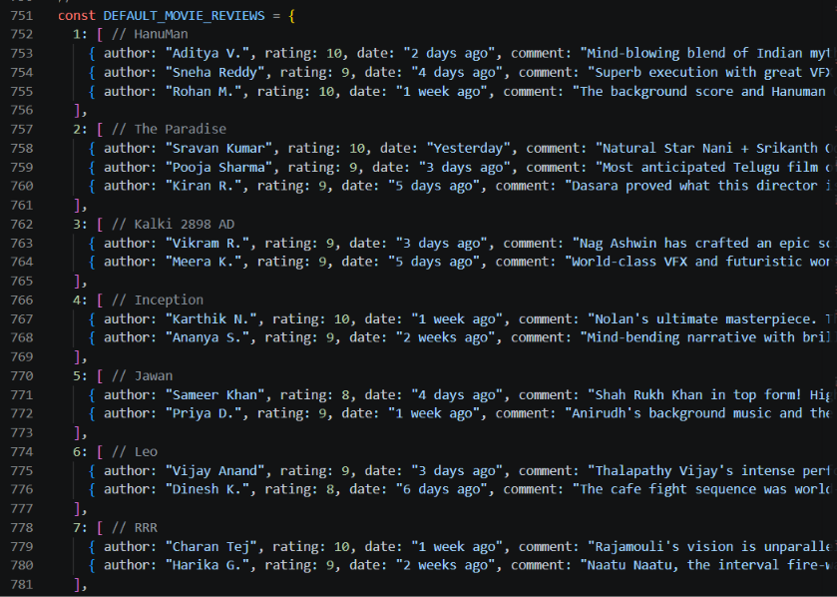
Figure 14. JavaScript
JavaScript calculates the subtotal by adding the prices of all selected seats. It then adds a fixed ₹30 convenience fee when at least one seat is selected to calculate the final booking amount.
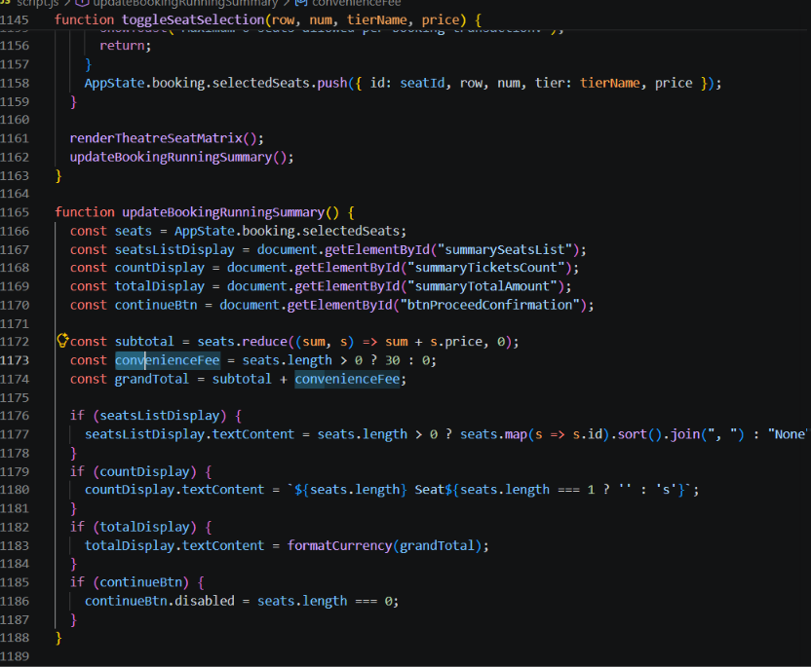
Figure 15. JavaScript for the Calculation of Amount

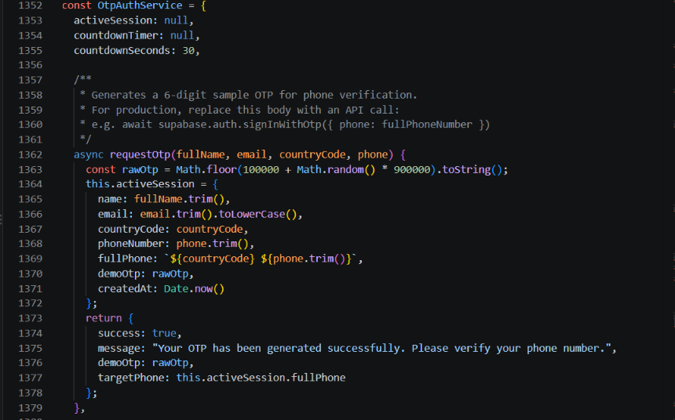
Figure 19. JavaScript for OTP Generation Logic
JavaScript enables users to select a city and explore available movie theatres based on the selected location. It helps users to proceed with movie selection and booking.
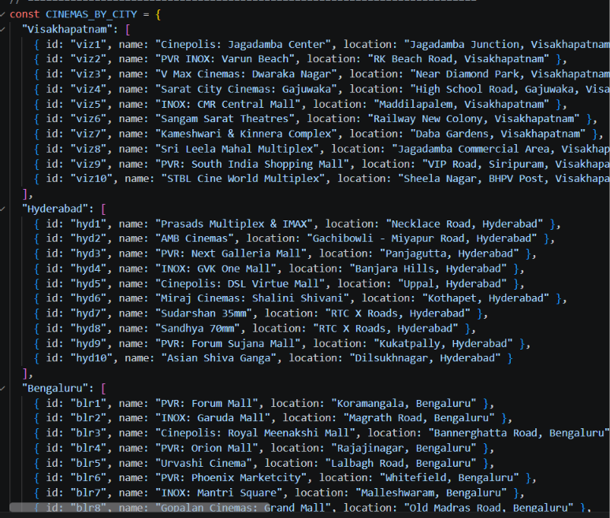
Figure 20. JavaScript for Movie Theatre Location

The Movie Explorer application allows users to select a theatre, choose available seats, and book tickets for their preferred movie. It automatically calculates the ticket subtotal and adds a ₹30 convenience fee when at least one seat is selected, displaying the final booking amount.

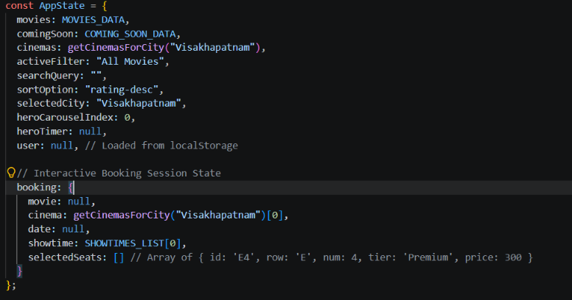
Figure 20. JavaScript for the Booking of the Ticket

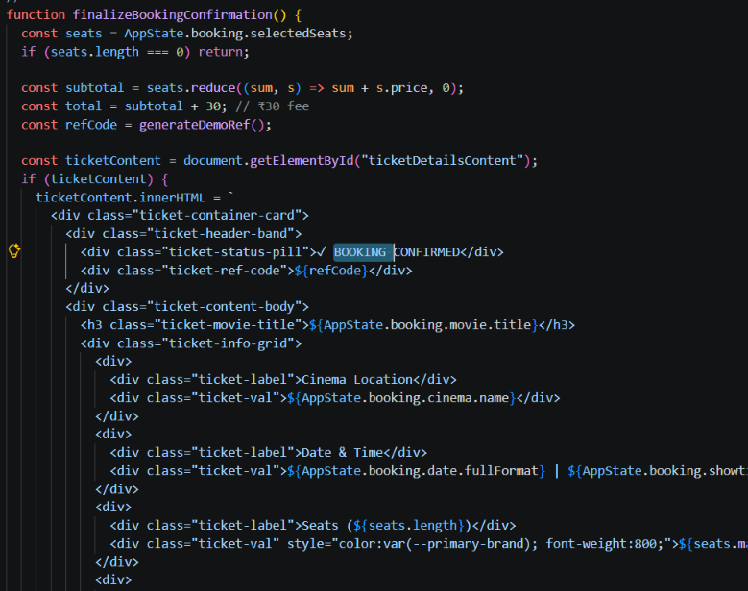
Figure 21. JavaScript for Booking Confirmation

5. Testing
5.1 Test Plan
Unit Testing: Unit testing is a software development process in which the smallest testable parts of an application, called units, are tested individually to verify their proper operation. In the Movie Explorer application, movie search, genre filtering, rating display, movie ranking, sorting, seat selection, booking total calculation, and form validation are tested individually, wherever applicable.
Integration Testing: The movie data, JavaScript functions, user interface, and browser storage are tested together to ensure that movie information is displayed correctly, search and filter results work as expected, ratings and rankings are handled correctly, and booking details and total amounts are calculated accurately.
System Testing: The complete Movie Explorer application is tested from the user's perspective. The testing covers browsing movies, searching for movies, filtering by genre, viewing movie details, sorting by rating or release year, selecting seats, and completing the booking flow. The application is also checked at different screen sizes to verify usability and responsiveness.

5.2 Test Report

The following table lists the test cases and their results:
ID | Test Case | Expected Result | Actual | Status
T1 |  | Home page with movie listings is displayed |  | Pass
  Open the Movie Explorer application
  Movie listings displayed successfully
T2 |  |  |  | Pass
  Search for a valid movie title
  Matching movie is displayed
  Matching movie displayed
T3 |  |  |  | Pass
  Search for an invalid movie title
  No results message is displayed
  No matching movies found
T4 |  |  | Movies filtered by genre successfully | Pass
  Filter movies by genre
  Only movies belonging to the selected genre are displayed
T5 |  |  |  | Pass
  Sort movies by rating
  Movies are arranged according to rating
  Movies sorted by rating
T6 |  |  | Movie details displayed successfully | Pass
  View movie details
  Movie title, poster, description, release year, genre, and rating are displayed
T7 | Calculate booking total | Total amount includes the applicable convenience fee | Total amount calculated successfully | Pass
T8 | Submit a form with required fields empty | Validation message is displayed |  | Pass
  Validation message displayed
T9 | Reload the application | Movie information and saved data remain available, if persistence is implemented | Data checked after reload | Pass
Table 2. Test Report
Test Environment
- Operating System: Windows 10 / Windows 11
- Browsers: Chromium-based browsers, such as Google Chrome and Microsoft Edge
- Technologies: HTML5, CSS3 and JavaScript
- Development Tools: Visual Studio Code and Live Server
- Testing Tools: Browser developer tools for inspecting elements, debugging JavaScript and identifying errors
Observations
- Movie Search: The search functionality was tested to check whether users could find movies by entering titles or relevant keywords.
- Movie Browsing: The application was checked to ensure that the available movie collection was displayed correctly.
- Genre Navigation: Genre-based browsing was tested to verify that users could explore movies by category, where this feature was implemented.
- Movie Details: The display of available movie information was checked for proper presentation and readability.
- Local Dataset: The application was tested to confirm that movie information was retrieved from the local dataset without requiring an external movie database API.
- User Interface: The layout was checked on desktop and smaller screen sizes to evaluate its responsiveness and usability.
- Browser Compatibility: The website was tested in compatible browsers, such as Google Chrome and Microsoft Edge, to identify display or functionality issues.
- Error Handling: Search behaviour was checked for empty inputs, incorrect movie titles and cases where no matching results were available, where applicable.
Limitation Found
- Repeated Support Actions: In the current version of Movie Explorer, user login and authentication are not available. Therefore, user-specific actions cannot be reliably restricted to one action per user. Account-based features can be introduced in future versions.
- Movie Data Storage: The application uses a local movie dataset, so the available movie information is limited to the data included in the project. Integration with an external movie database API can help provide more extensive and updated information in future versions.
- Personalized Features: Features such as synchronized watchlists, user-specific favourites and personalized recommendations are not available in the current version. These can be implemented through user authentication and backend integration in future development.
Test Summary
The test cases listed in Table 2 were evaluated to verify the functionality of the Movie Explorer application. The movie search feature returned matching results for valid titles and displayed an appropriate message when no matching movies were found. Genre filtering and movie sorting worked as expected, and the movie details page displayed the available information, including the title, poster, description, release year, genre, and rating. The seat selection feature updated the booking subtotal, and the total booking amount was calculated with the applicable convenience fee. Form validation was also tested to ensure that required fields were completed. The application was further evaluated for usability and responsiveness across different screen sizes.

6. Installation Instructions

Movie Explorer does not require Node.js, npm, or a database in its current version. The prerequisites for running the application on a local machine are a modern web browser and, for development, Visual Studio Code with the Live Server extension. Follow the instructions below to install and run the application.
a. Create a folder for the project, for example, movie-explorer, and save the project files, including the HTML, CSS, JavaScript, and any required local movie dataset or image files, inside it.

b. Install Visual Studio Code and install the Live Server extension from the Extensions panel.

c. Open the project folder in Visual Studio Code and locate the main HTML file, such as index.html or the actual HTML filename used in the project.

d. Open the HTML file and click Go Live in the status bar, or right-click the file and select Open with Live Server. The application will open in the default web browser.

e. Alternatively, if the project does not require a local development server, double-click the main HTML file to open it directly in a compatible web browser.

f. Verify that the movie listings, search functionality, images and other implemented features display correctly. Ensure that all required project files are present in their expected locations.

7. End-User Instructions

Movie Explorer provides users with the following options:
- Browse available movies.
- Search for movies by title or keywords.
- Explore movies by genre.
- View available movie details.
To browse movies, open the Movie Explorer website in a compatible web browser. Navigate through the available movie collection to explore the films displayed on the home page or other sections of the application.
To search for a movie, locate the search bar, enter the movie title or a relevant keyword, and view the matching results. If the required movie does not appear, check the spelling or try a different keyword. Search results depend on the information available in the local movie dataset.
To explore movies by genre, select the required genre from the available category options. The application displays movies belonging to that category, provided genre-based browsing is implemented in the current version.
To view movie details, select a movie from the displayed collection. The application presents the available information, such as the movie title, description, release year, genre, poster and rating, depending on the details included in the dataset.
To use available filtering or sorting options, select the required criteria, if these features are supported by the current version. These options can help users narrow down the movie collection and find films according to their preferences.
For the best experience, use a modern web browser and ensure that all required project files, including the local movie dataset and image files, are available. Since the current version uses a local dataset and does not depend on an external movie database API, the movies and information displayed are limited to the content included in the project.
Understanding the Movie Explorer Features
Movie Explorer provides several features to help users discover and explore movies. The available features and their purposes are described below.
Stage | Meaning
Browse Movies
  Displays the available movie collection for users to explore.
Search Movies | .
  Helps users find movies by entering a title or relevant keyword.
Explore Genres
  Allows users to discover movies belonging to different genres, if supported by the current version.
View Movie Details
  Displays available information about a selected movie, such as its title, description, release year and genre.
Search Results
  Displays movies that match the user's search query. If no matching movie is found, an appropriate message can be displayed.
Responsive Interface | Helps the website adapt to different screen sizes, including desktops, tablets and mobile devices.

Tips for Better Movie Exploration
- Use specific movie titles: Enter the correct movie name or relevant keywords in the search bar to find movies more easily.
- Explore different genres: Browse categories such as action, comedy, drama, thriller and romance to discover movies that match your interests.
- Check movie details: Review the available information, such as the movie description, release year, genre and rating, before selecting a movie.
- Try different search terms: If a movie does not appear, check the spelling or try a shorter keyword.
- Explore new movies: Browse different categories instead of searching only for familiar titles to discover films you may enjoy.
- Use available filters and sorting options: If supported by the current version, use them to narrow down the movie collection according to your preferences.
- Check the available collection: Movie Explorer uses a local movie dataset, so some movies may not be available in the current version.
- Keep future enhancements in mind: Features such as personalized recommendations, watchlists and updated movie information can make movie discovery even more convenient in future versions.
Frequently Asked Questions
Q. How can I find a specific movie?
You can use the search feature to enter the movie title or a relevant keyword and find the movie in the available collection.
Q. How can I explore movies of a particular genre?
You can select a genre to explore the movies available in that category, depending on the features supported by the current version.
Q. Can I view details about a movie?
Yes. You can select a movie from the available collection to view its displayed information and other details supported by the application.
Q. Does Movie Explorer provide personalized movie recommendations?
Personalized recommendations are not currently available unless explicitly implemented in the application. This feature can be introduced in future versions to suggest movies based on users’ interests and preferences.
8. Future Work

Some of the possible enhancements and improvements in the Movie Explorer system are:

- Integration with an external movie database API to retrieve updated movie information.

- User login and authentication.

- Personalized movie recommendations based on users’ interests.

- Watchlist and favourite movie management.

- Advanced search, filtering and sorting options.

- Movie ratings and user reviews.

- Backend server and database integration.

- Mobile application development.

- Multi-language support.

- Cloud deployment and performance improvements.

External Movie Database API Integration: An external movie database API, such as The Movie Database (TMDB) API, can be integrated to retrieve updated information about movies, including titles, descriptions, genres, release dates, ratings and posters. This would allow Movie Explorer to provide a larger and more current collection than the existing local dataset.

User Login and Authentication: A user authentication system can be introduced to allow users to create accounts and securely access their personal preferences. This would help provide a personalized experience and enable users to maintain their movie-related activities across sessions.

Personalized Movie Recommendations: Recommendation techniques can be implemented to suggest movies based on users’ favourite genres, previously selected movies, ratings and viewing preferences. This would help users discover films that match their interests.

Watchlist and Favourite Movie Management: A watchlist feature can allow users to save movies they want to watch later. Users could also mark movies as favourites and organize their selections for convenient access. With backend and cloud storage, these lists could be synchronized across multiple devices.

Advanced Search and Filtering: Advanced search options can be introduced to help users find movies based on criteria such as genre, release year, language, rating and popularity. Sorting options could further improve the movie browsing experience.

Movie Ratings and User Reviews: Users could be allowed to rate movies and share their reviews. This information could help other users make informed decisions about which movies to watch.

Backend Server and Database Integration: A backend server using technologies such as Node.js and Express.js, together with a database such as MySQL or PostgreSQL, can be implemented to manage user accounts, watchlists, ratings and reviews centrally. This would support data synchronization and make the application more scalable.

Mobile Application Development: A dedicated mobile application can be developed for Android and iOS devices. It would provide convenient access to movie discovery features through a mobile-friendly interface.

Multi-language Support: Support for multiple languages can be added to make the application accessible to a wider audience. Movie descriptions and interface elements could be displayed in users’ preferred languages wherever translations are available.

Cloud Deployment and Performance Improvements: The application can be deployed on a cloud platform to improve accessibility and scalability. Performance can be enhanced through optimized images, efficient data loading, caching and responsive design for different screen sizes.

These future enhancements can transform Movie Explorer from a basic movie browsing website into a comprehensive movie discovery platform that provides updated information, personalized recommendations and a more engaging experience for users.

9. Summary

Movie Explorer provides a practical digital solution for discovering and exploring movies through a single, user-friendly platform. It demonstrates how front-end web technologies such as HTML, CSS, and JavaScript can be used to create an interactive website that organizes movie information and makes it easier for users to search for films and explore different genres. By presenting available movie details in a structured format and using a local movie dataset, Movie Explorer offers a simple and convenient movie discovery experience without requiring an external movie database API. The project also provides a foundation for future improvements, such as personalized recommendations, user accounts, watchlists, and real-time movie information.

Objectives Achieved

- A user-friendly web application has been developed to provide a single platform for browsing and exploring movies from different genres.
- A movie search feature has been included to help users find specific movies quickly using their titles or keywords.
- Movie information is displayed in an organized format, making it easier for users to explore the available collection.
- Genre-based browsing helps users discover movies according to their interests and preferences.
- A simple and interactive interface has been designed to improve the overall movie discovery experience.
- The application has been developed using HTML, CSS, and JavaScript, demonstrating the practical use of front-end web technologies.
- A local movie dataset has been used to display movie information without depending on an external movie database API.
- The project provides a foundation for future enhancements, including personalized recommendations, user accounts, watchlists, and real-time movie information.

Advantages of the System
Movie Explorer makes discovering and exploring movies simple and convenient. Users can browse the available movie collection, search for specific titles, and explore movies by genre through a user-friendly interface. The application organizes movie information in one place, helping users find relevant details without visiting multiple websites. Since the system is developed using HTML, CSS, and JavaScript and uses a local movie dataset, it is easy to set up and run in a web browser without requiring a dedicated backend server. The application is also cost-effective for a basic implementation and can be enhanced in the future with features such as online movie data, personalized recommendations, and watchlists.
Limitations
The current version of Movie Explorer uses a local movie dataset stored within the application, so the available movie information is limited to the data included in the project. It does not currently provide user login, personalized recommendations, or the ability to save and synchronize watchlists across different devices. Some advanced features, such as real-time movie information, automatic notifications, and personalized user preferences, are also not available in the present version.
These limitations can be addressed in future versions by integrating an external movie database API, adding user authentication, implementing cloud-based data storage, and introducing personalized recommendations and notification features.

Conclusion

The Movie Explorer project demonstrates how web technologies such as HTML, CSS, and JavaScript can be used to develop a user-friendly platform for discovering and exploring movies. The website provides convenient features for browsing movie collections, searching for movies, exploring genres, and viewing available movie information in an organized and interactive interface.
The project aims to make movie discovery simpler, faster, and more enjoyable by bringing movie information together in one place. With future enhancements such as an external movie database API, personalized recommendations, user accounts, watchlists, and advanced search filters, Movie Explorer can evolve into a comprehensive movie discovery platform that offers a more personalized and engaging experience for users.

10. Reference

- MDN Web Docs – HTML
https://developer.mozilla.org/en-US/docs/Web/HTML
- MDN Web Docs – CSS
https://developer.mozilla.org/en-US/docs/Web/CSS
- MDN Web Docs – JavaScript
https://developer.mozilla.org/en-US/docs/Web/JavaScript
- MDN Web Docs – JavaScript Array Methods
https://developer.mozilla.org/enUS/docs/Web/JavaScript/Reference/Global_Objects/Array
- MDN Web Docs – Array Filter Method
https://developer.mozilla.org/enUS/docs/Web/JavaScript/Reference/Global_Objects/Array/filter
- MDN Web Docs – CSS Grid Layout
https://developer.mozilla.org/en-US/docs/Web/CSS/CSS_grid_layout
- MDN Web Docs – CSS Media Queries
https://developer.mozilla.org/enUS/docs/Web/CSS/CSS_media_queries/Using_media_queries
- Visual Studio Code Documentation
https://code.visualstudio.com/docs

